**GOOGLE LENS APPLICATION TECHNOLOGY**

**EZRA DLAMA**

**(ST/CS/ND/20/017)**

**A SEMINAR SUBMITED TO THE DEPERTMENT OF COMPUTER SCIENCE, SCHOOL OF SCIENCEAND TECHNOLOGY, FEREAL POLYTECHNIC MUBI, ADAMAWA STATE NIGERIA**

**NOVEMBER, 2022**

**GOOGLE LENS APPLICATION TECHNOLOGY**

**EZRA DLAMA**

**(ST/CS/ND/20/017)**

**A SEMINAR SUBMITED TO THE DEPERTMENT OF COMPUTER SCIENCE, SCHOOL OF SCIENCE AND TECHNOLOGY, FEDERAL POLYTECNIC MUBI, ADAMAWA STATE NIGERIA**

**IN PARTIAL FULFILLMENT OF THE REQUIREMENT FOR THE AWARD OF NATIONAL DIPLOMA (ND) IN COMPUTER SCCIENCE**

**NOVEMBER, 2022**

**Abstract**

*Google’s Newest Photo Tool can identify what’s in Pictures Better than a Human. Artificial Intelligence powered Google Lens can identify types of flowers. At Google I/O 2017 the company showed off its new Google Lens technology. This All powered usage makes benefit of visual recognition to provide information about things and objects that smartphone's camera is pointed at such as identifying flower type or providing reviews. This paper aims to classify the images and gives proposal as Google lens as image classifier readily available mobile app in our smart phone.*

**Keywords**: Information Technology, Image Processing, Image classification, Google lens.

**Introduction**

Google Lens enables you to point your phone at something, such as a specific flower, and then ask Google Assistant what the object you're pointing at is. You'll not only be told the answer, but you'll get suggestions based on the object, like nearby florists, in the case of a flower. Other examples of what Google Lens can do include being able to take a picture of the SSID sticker on the back of a Wi-Fi router, after which your phone will automatically connect to the Wi-Fi network without you needing to do anything else. Yep, no more crawling under the cupboard in order to read out the password whilst typing it in your phone. Now, with Google Lens, you can literally point and shoot (Elkin et al., 2016).

Google Lens will recognise restaurants, clubs, cafes, and bars, too, presenting you with a pop-up window showing reviews, address details and opening times. It's the ability to recognise everyday objects that's impressive. It will recognise a hand and suggest the thumbs up emoji, which is a bit of fun, but point it at a drink, and it will try and figure out what it is. Tested this functionality with a glass of white wine. It didn't suggest white wine to us, but it did suggest a whole range of other alcoholic drinks, letting you then tap through to see what they are, how to make them, and so on. That shows that, while Lens is fast and clever, it's not always accurate (Gilbert, 2014).

At present, mobile phone is an important role in our life for communication like calling, messaging etc. Mobile phone replaces numerous of electric and electronic devices in our life nowadays because, all the features are already available in mobile phone. Here we quote a few numbers of examples such as clock, alarm, notes, calculator, telephone directory, calendar, FM radio, music player, memo, camera, photo album and so on. Currently whenever we are in need of the previous devices, mobile phone is much more enough to all the process. Also, in smart phones, there are add up to quantity of preferences whatever we can do it computers. But in this paper, the mobile app, called as Google Lens acts as an image classifier using artificial intelligence and vision techniques. In the concept of image classification or clustering, we need dataset for both training and testing phase, a better algorithm is one which gives higher accuracy and software or tools to implement (Anushya, 2019).

Now, the mobile app, Google Lens can replace all the image processing steps such that there is no need of training phase, algorithm and software. Google Lens is an [image recognition](https://en.wikipedia.org/wiki/Image_recognition) technology developed by [Google](https://en.wikipedia.org/wiki/Google), designed to bring up relevant information n related to objects it identifies using visual analysis based on a [neural network](https://en.wikipedia.org/wiki/Neural_network). First announced during [Google I/O](https://en.wikipedia.org/wiki/Google_I/O) 2017 it was first provided as a standalone app, later being integrated into Android's standard camera app (Anushya, 2019).

**Literature Review.**

2.1 General situation on the necessity of Google Lens in curricula

The world is becoming digital and technological, which directly affects the learning

process and it creates challenges to education. The classical educational environment

is stable, based on pedagogical traditions, involves the formation of hard skills. In

Ukraine, the classical educational environment is represented by curricula on various

subjects that are required for the performance of all teachers, a list of textbooks that are

recommended for use during the educational process and a number of legislative acts

of the Ministry of Education and Science. However, considering the New Ukrainian

school concept, educational society faces challenges on the implementation of virtual

instruments (learning environment) [2; 3].

Unlike classical educational environment, virtual learning environment is constantly

changing in connection with the constant scientific and technical process, it is aimed at

the development of creativity [12]. Virtual learning environments include digital

programs and websites. The most program helps to analyze experimental data,

mathematically process them. Thanks to them, you can successfully apply a learning

model through a study in which a student analyzes the results obtained by himself or

others by establishing experimental data as if discovering the basic laws of nature.

Special and most modern of them are those which include elements of virtual and

augmented reality due to their ability to increase student’s motivation [6; 19].

Previously, we substantiated the need to implement Google Lens approach in the

educational process [16]. However, there wasn’t shown the efficiency of Google Lens.

Therefore, this work aims to analyze the possibility of Google Lens using in educational

institutions to provide STEM-research projects on botany. To achieve the aims next

tasks were indicated:

2.1 General situation on the necessity of Google Lens in curricula

The world is becoming digital and technological, which directly affects the learning

process and it creates challenges to education. The classical educational environment

is stable, based on pedagogical traditions, involves the formation of hard skills. In

Ukraine, the classical educational environment is represented by curricula on various

subjects that are required for the performance of all teachers, a list of textbooks that are

recommended for use during the educational process and a number of legislative acts

of the Ministry of Education and Science. However, considering the New Ukrainian

school concept, educational society faces challenges on the implementation of virtual

instruments (learning environment) [2; 3].

Unlike classical educational environment, virtual learning environment is constantly

changing in connection with the constant scientific and technical process, it is aimed at

the development of creativity [12]. Virtual learning environments include digital

programs and websites. The most program helps to analyze experimental data,

mathematically process them. Thanks to them, you can successfully apply a learning

model through a study in which a student analyzes the results obtained by himself or

others by establishing experimental data as if discovering the basic laws of nature.

Special and most modern of them are those which include elements of virtual and

augmented reality due to their ability to increase student’s motivation [6; 19].

Previously, we substantiated the need to implement Google Lens approach in the

educational process [16]. However, there wasn’t shown the efficiency of Google Lens.

Therefore, this work aims to analyze the possibility of Google Lens using in educational

institutions to provide STEM-research projects on botany. To achieve the aims next

tasks were indicated:

2.1 General situation on the necessity of Google Lens in curricula

The world is becoming digital and technological, which directly affects the learning

process and it creates challenges to education. The classical educational environment

is stable, based on pedagogical traditions, involves the formation of hard skills. In

Ukraine, the classical educational environment is represented by curricula on various

subjects that are required for the performance of all teachers, a list of textbooks that are

recommended for use during the educational process and a number of legislative acts

of the Ministry of Education and Science. However, considering the New Ukrainian

school concept, educational society faces challenges on the implementation of virtual

instruments (learning environment) [2; 3].

Unlike classical educational environment, virtual learning environment is constantly

changing in connection with the constant scientific and technical process, it is aimed at

the development of creativity [12]. Virtual learning environments include digital

programs and websites. The most program helps to analyze experimental data,

mathematically process them. Thanks to them, you can successfully apply a learning

model through a study in which a student analyzes the results obtained by himself or

others by establishing experimental data as if discovering the basic laws of nature.

Special and most modern of them are those which include elements of virtual and

augmented reality due to their ability to increase student’s motivation [6; 19].

Previously, we substantiated the need to implement Google Lens approach in the

educational process [16]. However, there wasn’t shown the efficiency of Google Lens.

Therefore, this work aims to analyze the possibility of Google Lens using in educational

institutions to provide STEM-research projects on botany. To achieve the aims next

tasks were indicated:

2.1 General situation on the necessity of Google Lens in curricula

The world is becoming digital and technological, which directly affects the learning

process and it creates challenges to education. The classical educational environment

is stable, based on pedagogical traditions, involves the formation of hard skills. In

Ukraine, the classical educational environment is represented by curricula on various

subjects that are required for the performance of all teachers, a list of textbooks that are

recommended for use during the educational process and a number of legislative acts

of the Ministry of Education and Science. However, considering the New Ukrainian

school concept, educational society faces challenges on the implementation of virtual

instruments (learning environment) [2; 3].

Unlike classical educational environment, virtual learning environment is constantly

changing in connection with the constant scientific and technical process, it is aimed at

the development of creativity [12]. Virtual learning environments include digital

programs and websites. The most program helps to analyze experimental data,

mathematically process them. Thanks to them, you can successfully apply a learning

model through a study in which a student analyzes the results obtained by himself or

others by establishing experimental data as if discovering the basic laws of nature.

Special and most modern of them are those which include elements of virtual and

augmented reality due to their ability to increase student’s motivation [6; 19].

Previously, we substantiated the need to implement Google Lens approach in the

educational process [16]. However, there wasn’t shown the efficiency of Google Lens.

Therefore, this work aims to analyze the possibility of Google Lens using in educational

institutions to provide STEM-research projects on botany. To achieve the aims next

tasks were indicated:

2.1 General situation on the necessity of Google Lens in curricula

The world is becoming digital and technological, which directly affects the learning

process and it creates challenges to education. The classical educational environment

is stable, based on pedagogical traditions, involves the formation of hard skills. In

Ukraine, the classical educational environment is represented by curricula on various

subjects that are required for the performance of all teachers, a list of textbooks that are

recommended for use during the educational process and a number of legislative acts

of the Ministry of Education and Science. However, considering the New Ukrainian

school concept, educational society faces challenges on the implementation of virtual

instruments (learning environment) [2; 3].

Unlike classical educational environment, virtual learning environment is constantly

changing in connection with the constant scientific and technical process, it is aimed at

the development of creativity [12]. Virtual learning environments include digital

programs and websites. The most program helps to analyze experimental data,

mathematically process them. Thanks to them, you can successfully apply a learning

model through a study in which a student analyzes the results obtained by himself or

others by establishing experimental data as if discovering the basic laws of nature.

Special and most modern of them are those which include elements of virtual and

augmented reality due to their ability to increase student’s motivation [6; 19].

Previously, we substantiated the need to implement Google Lens approach in the

educational process [16]. However, there wasn’t shown the efficiency of Google Lens.

Therefore, this work aims to analyze the possibility of Google Lens using in educational

institutions to provide STEM-research projects on botany. To achieve the aims next

tasks were indicated:

2.1 General situation on the necessity of Google Lens in curricula

The world is becoming digital and technological, which directly affects the learning

process and it creates challenges to education. The classical educational environment

is stable, based on pedagogical traditions, involves the formation of hard skills. In

Ukraine, the classical educational environment is represented by curricula on various

subjects that are required for the performance of all teachers, a list of textbooks that are

recommended for use during the educational process and a number of legislative acts

of the Ministry of Education and Science. However, considering the New Ukrainian

school concept, educational society faces challenges on the implementation of virtual

instruments (learning environment) [2; 3].

Unlike classical educational environment, virtual learning environment is constantly

changing in connection with the constant scientific and technical process, it is aimed at

the development of creativity [12]. Virtual learning environments include digital

programs and websites. The most program helps to analyze experimental data,

mathematically process them. Thanks to them, you can successfully apply a learning

model through a study in which a student analyzes the results obtained by himself or

others by establishing experimental data as if discovering the basic laws of nature.

Special and most modern of them are those which include elements of virtual and

augmented reality due to their ability to increase student’s motivation [6; 19].

Previously, we substantiated the need to implement Google Lens approach in the

educational process [16]. However, there wasn’t shown the efficiency of Google Lens.

Therefore, this work aims to analyze the possibility of Google Lens using in educational

institutions to provide STEM-research projects on botany. To achieve the aims next

tasks were indicated

2.1 General situation on the necessity of Google Lens in curricula

The world is becoming digital and technological, which directly affects the learning

process and it creates challenges to education. The classical educational environment

is stable, based on pedagogical traditions, involves the formation of hard skills. In

Ukraine, the classical educational environment is represented by curricula on various

subjects that are required for the performance of all teachers, a list of textbooks that are

recommended for use during the educational process and a number of legislative acts

of the Ministry of Education and Science. However, considering the New Ukrainian

school concept, educational society faces challenges on the implementation of virtual

instruments (learning environment) [2; 3].

Unlike classical educational environment, virtual learning environment is constantly

changing in connection with the constant scientific and technical process, it is aimed at

the development of creativity [12]. Virtual learning environments include digital

programs and websites. The most program helps to analyze experimental data,

mathematically process them. Thanks to them, you can successfully apply a learning

model through a study in which a student analyzes the results obtained by himself or

others by establishing experimental data as if discovering the basic laws of nature.

Special and most modern of them are those which include elements of virtual and

augmented reality due to their ability to increase student’s motivation [6; 19].

Previously, we substantiated the need to implement Google Lens approach in the

educational process [16]. However, there wasn’t shown the efficiency of Google Lens.

Therefore, this work aims to analyze the possibility of Google Lens using in educational

institutions to provide STEM-research projects on botany. To achieve the aims next

tasks were indicated

General situation on the necessity of Google Lens in curricula the world is becoming digital and technological, which directly affects the learning process and it creates challenges to education. The classical educational environment is stable, based on pedagogical traditions, involves the formation of hard skills. In Ukraine, the classical educational environment is represented by curricula on various subjects that are required for the performance of all teachers, a list of textbooks that are recommended for use during the educational process and a number of legislative acts of the Ministry of Education and Science (Anushya, 2019).

However, considering the New Ukrainian school concept, educational society faces challenges on the implementation of virtual instruments (learning environment). Unlike classical educational environment, virtual learning environment is constantly changing in connection with the constant scientific and technical process, it is aimed at the development of creativity (Khan et al. 2016).

Virtual learning environments include digital programs and websites. The most program helps to analyze experimental data, mathematically process them. Thanks to them, you can successfully apply a learning model through a study in which a student analyzes the results obtained by himself or others by establishing experimental data as if discovering the basic laws of nature. Special and most modern of them are those which include elements of virtual and augmented reality due to their ability to increase student’s motivation. Previously, we substantiated the need to implement Google Lens approach in the educational process. However, there wasn’t shown the efficiency of Google Lens (Bilyk et al., 2015).

Google announced Google Lens, with which Google can "understand what we're looking at and help us take action," CEO Sundar Pichai said. "We can give you the right information in a meaningful way." New Google's Lens enables users to search with their phone's camera. Its augmented reality further than photo filters. Google launched Lens at first in the Assistant, its digital helper software, and in Google Photos. It will be available at an unspecified date "later this year (Gilbert, 2014).

**Benefits of Google Lens**

Aside from the scenarios described above, Google Lens offers the following features:

**Smart Text Selection:** You can point your phone's camera at text, then highlight that text within Google Lens, and copy it to use on your phone. So, for instance, imagine pointing your phone at a Wi-Fi password and being able to copy/paste it into a Wi-Fi login screen.

**Smart Text search:** When you highlight text in Google Lens, you can also search that text with Google. This is handy if you need to look up a definition of word, for instance.

**Shopping**: If you see a dress you like while shopping, Google Lens can identify that piece and similar articles of clothing. This works for just about any item you can think of, accessing shopping or reviews.

**Google homework questions**: That's right, you can just scan the question and see what Google comes up with.

**Search around you:** If you point your camera around you, Google Lens will detect and identify your surroundings. That might be details on a landmark or details about types of food - including recipes.

**Features of Google Lens**

**Scan and translate text:** Translate text in real time, look up words, add events to your calendar, call a number, and more. Or just copy and paste to save some time.

**Find a look you like:** See an outfit that caught your eye? Or a chair that's perfect for your living room? Get inspired by similar clothes, furniture, and home decor—without having to describe what you're looking for in a search box.

**See what’s popular on menus:** Wondering what to order at a restaurant? Look up dishes and see what’s popular, right on the menu, with photos and reviews from Google Maps.

**Explore nearby places:** Learn more about popular landmarks. See ratings, hours of operation, historical facts and more.

**Identify plants and animals:** Find out what plant is in your friend's apartment, or what kind of dog you saw in the park.

**Step-by-step homework help**: Stuck on a problem? Quickly find explainers, videos, and results from the web for math, history, chemistry, biology, physics, and more.

**Google Lens and its Role Education**

Mobile phone nowadays is a powerful scientific instrument. However, the potential of it still not fully understood and presented. One of the companies who are creating new digital software which can be used in education is Google who creates instruments such as Google Lens. Google Lens is an image recognition technology based on neural networks and developed by Google. Having determined the species of animal or plant, one can further study its biological properties. The main positive aspects of using Google Lens in our opinion are (Budnyk, 2018):

Provided by the possibility to use personal phones any time of the research.

Interaction with any objects include biological

The possibility of research any object any time including during expeditionary researches

Creation of interaction between real and virtual worlds.

Google lens is integrated into both Google Photos and Google camera which can be used on any Android devices with Android 4.4 or higher or IOS. The access to Google Lens instrument is presented in Figure 1. Google Lens can be used in different parts of education such as Biology, Mineralogy, Architecture and history and Marketing to achieve additional information about the object and increase the motivation of the students (table 1) (Budnyk, 2018).

**Table 1. Using Google Lens in Different Fields of Education (Budnyk, 2018).**

|  |  |
| --- | --- |
| **Field science** | **Ways of using google lens** |
| Biology | Nowadays Google Lens is characterized by the possibility of biology objects recognition (animals, plants, etc.) |
| Mineralogy | Google lens can use the color and the structure of the minerals to analyze it (not available now, but we think it will be provided in the future) |
| Architecture and history | Analyzing the building and monuments |
| Marketing | Analyzing and searching for different real-life products such as clothes |

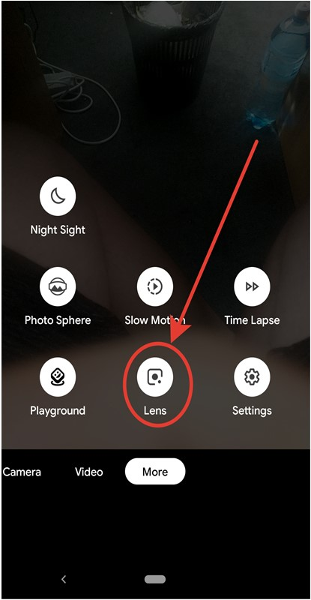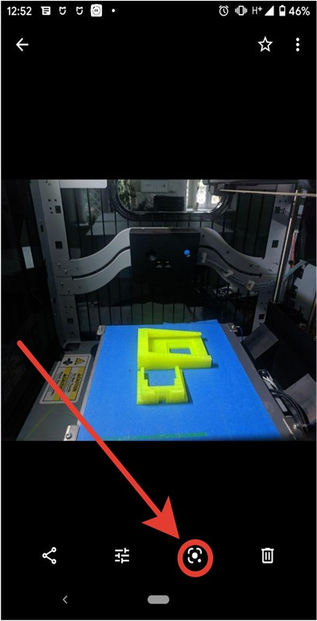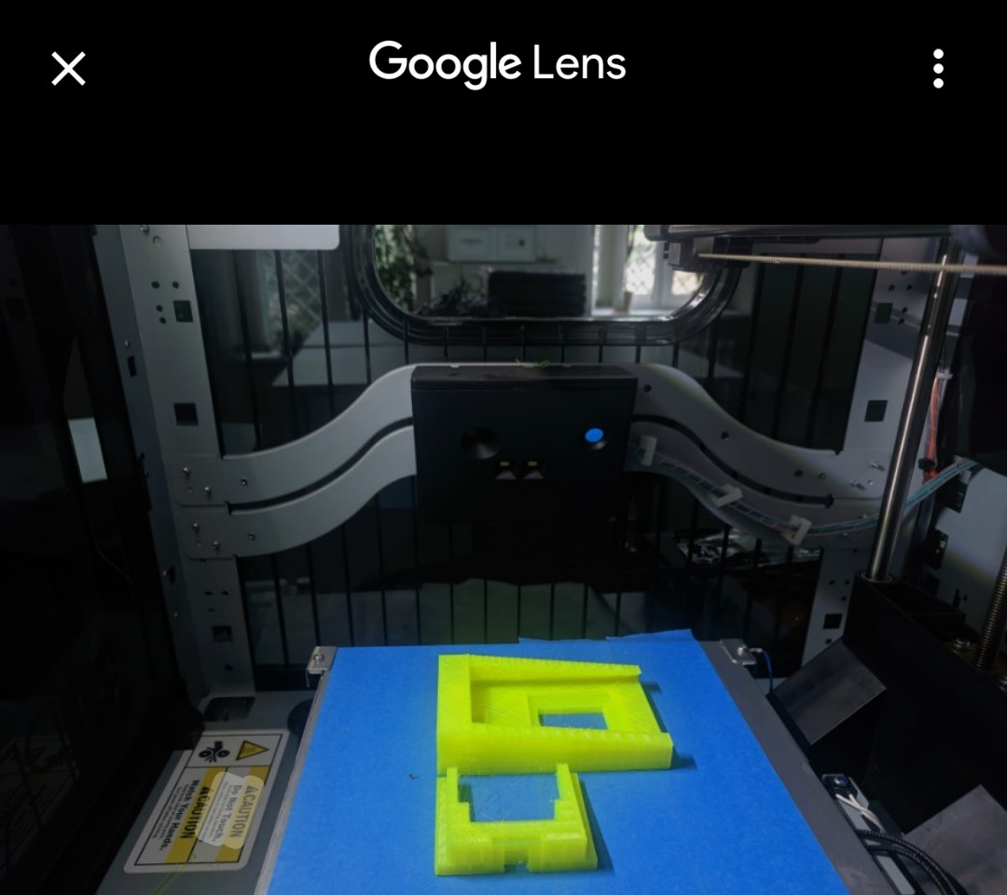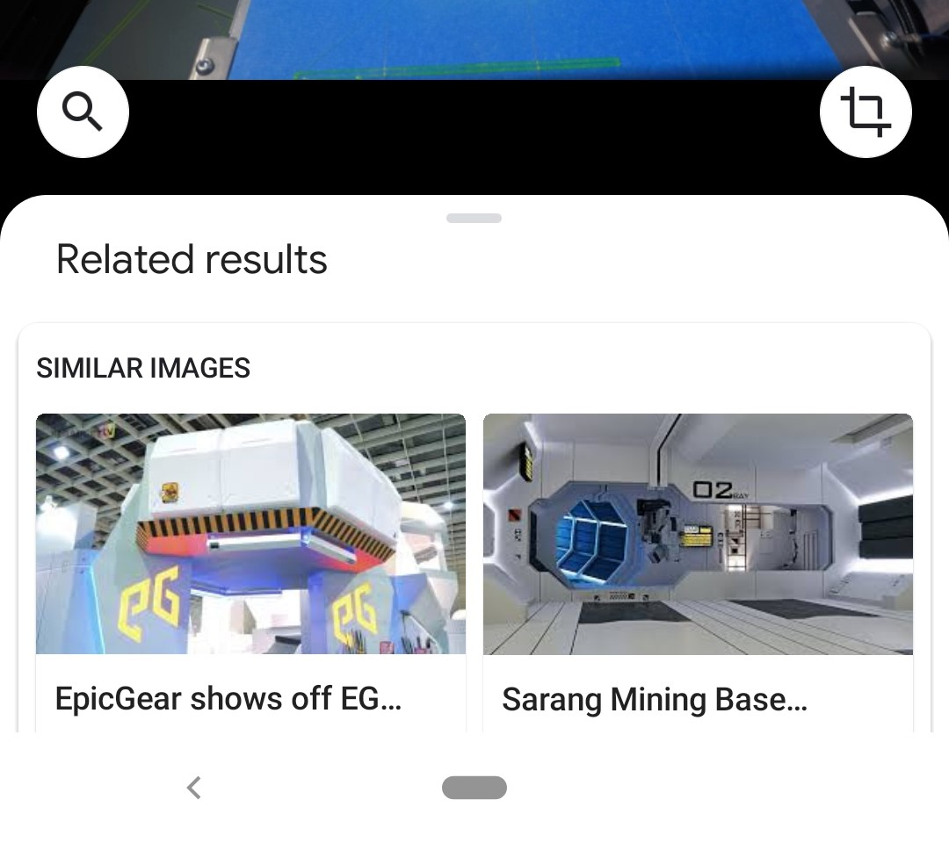

Figure 1: Google Lens instrument access (Budnyk, 2018).

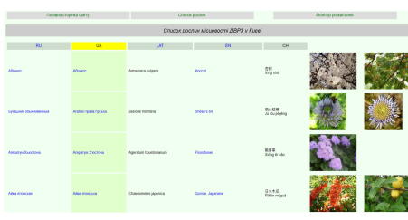

Figure 2: List of Plant of the Dneprovskiy District of Kiev (Budnyk, 2018).

Photo’s quality is an important factor to Google Lens. Therefore, it is necessary to classify each photo by main quality components – composition, resolution, digital noise.

## Conclusions

## In this paper, we have proposed the latest Mobile App, Google Lens as an Image Classifier explored for the purpose of flower classification. It is observed that using the Google Lens can achieve relatively a good classification accuracy when compared to any other available features. We have developed a new database of 20 classes of flowers, each class contains 150 flower images and experimented images of different datasets size we recorded the size effect on the classification accuracy.

**Recommendations**

Google Lens shows the high results of analyzing which gives reason to recommend

its implementation in the educational process.

2. It is better to plan classes on the gardens due to the fact that Google Lens shows

better results on the grass and trees analysis.

3. Based on the results of the article we modernize methods located in the

stemua.science.

4. Using of Google Lens in the educational process is a simple way to include principles

Google Lens shows the high results of analyzing which gives reason to recommend

its implementation in the educational process.

2. It is better to plan classes on the gardens due to the fact that Google Lens shows

better results on the grass and trees analysis.

3. Based on the results of the article we modernize methods located in the

stemua.science.

4. Using of Google Lens in the educational process is a simple way to include principles

Google Lens shows the high results of analyzing which gives reason to recommend

its implementation in the educational process.

2. It is better to plan classes on the gardens due to the fact that Google Lens shows

better results on the grass and trees analysis.

3. Based on the results of the article we modernize methods located in the

stemua.science.

4. Using of Google Lens in the educational process is a simple way to include principles

1. Google Lens shows the high results of analyzing which gives reason to recommend its implementation in the educational process.
2. The paper also recommends that it is better to plan classes on the gardens due to the fact that Google Lens shows better results on the grass and trees analysis.

## References

Anushya, A. (2019). Google Lens as an Image Classifier. *International Journal of Scientific Research in Computer Science Applications and Management Studies*, 8(6), 1953-2319.

Bilyk, Z., Shapovalov, Y., Shapovalov, V. & Atamas, A. (2015). Use of Ontological Resources of the Universal Network Information Educational Media, *Osvita ta rozvytok obdarovanoi osobystosti,* 1(72), 30–36.

Budnyk, O. (2018). Theoretical Principles of Using Steam-Technologies in the Preparation of the Teacher of the New Ukrainian School. *Journal of Vasyl Stefanyk Precarpathian National University* 5(1), 23–30.

Elkin, O., Hrynevych, L., Kalashnikova, S., Khobzey, P., Kobernyk, I., Kovtunets, V., Makarenko, O., Malakhova, O., Nanayeva, T., Shiyan, R., Usatenko, H. (2016). The New Ukrainian School: Conceptual principles of secondry school reform. Ministry of Education and Science of Ukraine Kiev. *CEUR Workshop Proceedings* 2433(22), 336–351.

Gilbert, J. (2014). Models and modelling: Routes to more authentic science education. *International Journal of Science and Mathematics Education,* 2(2), 115–130.

Khan, T., Johnston, K., Ophoff, J. (2016). The Impact of an Augmented Reality Application on Learning Motivation of Students. *Advances in Human-Computer Interaction,* 7(2), 1–14